Meat Industry Pallet Pilot Project
Carton size and pallet configuration information collection form
This information collection form needs to be completed for each different carton size and pallet configuration that leaves your establishment for the US market.
For information about the pallet pilot project please contact Des Bowler +61 412 124 480.
Please email the competed form and any photos to info@meatmessaging.com

Details about completion
Completed at: _________________________________________________________________________
Completed by: _______________________ Date completed: ________________________

Carton details
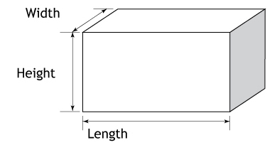
Establishment Number: ______________________
Width: _______________________
Height: _______________________
Length: _______________________
Please supply a photo of the carton end panel and a close up of a few carton labels.
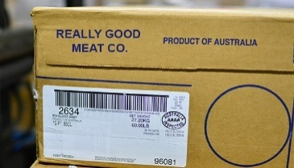
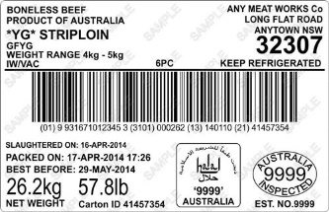
Carton Carton
End Label
Panel

Pallet details
If the cartons leave on a pallet in containers what is the pallet configuration: _____________ and count: _________
Use the examples below as a guide:
